St. Charles Women’s Group 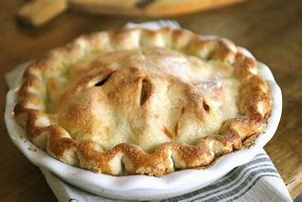

**Apple Pie Order Form**

The holidays are just around the corner! St. Charles Women’s Group will be making  
 **“Take & Bake” Apple Pies**. Pie price is: **$18.00**. Please submit money with order, payable to:   
ST. CHARLES CATHOLIC WOMEN’S GROUP.

Orders are requested by **November 9, 2024**.

Pick up will be **November 16th and 17th** after Mass ---- at the school cafeteria.

Please fill out the form below.

NAME: ________________________________________________________________________

PHONE NO: ___________________________________

QUANTITY: __________ X $18.00 = __________________ Check #__________ or Cash _____

DATE ORDERED: _____________________

For PCCW information:

Apple Pie (s) **picked up by customer on** ____________________________________(date)

St. Charles Women’s Group

**Your Receipt for Apple Pie Order**

NAME:_____________________________________________________________________  
  
QUANTITY: __________ X $18 = ____________ Check #__________ or Cash ________  
  
DATE ORDERED: _____________________